Guide: How to delete items out of user inbox

To be able to delete messages out of users inboxes you first need to create a *Content Search*. Content searches can be created inside the *Security & compliance* centre in the *Office 365 portal*.

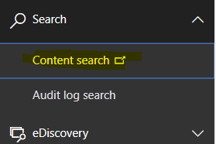

Click the new *guided search* button.

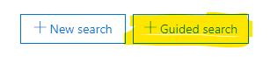

Enter a search name and description. Set the location to *Specific locations* and select the *Exchange email*.

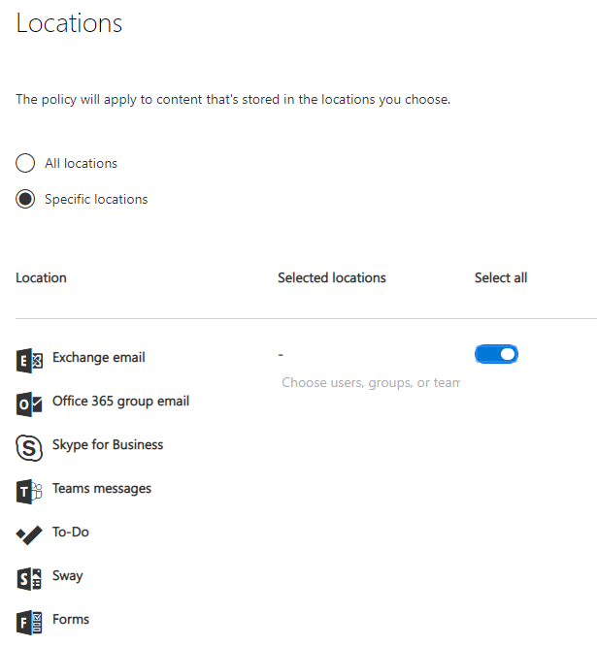

Enter query results to filter the emails you wish to delete or find.

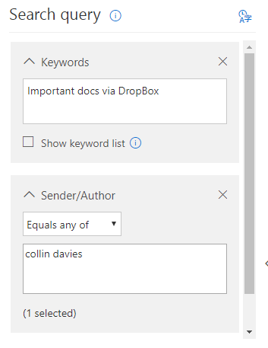

Once your happy that the results contain all the emails you wanted to find and delete press the *save & run* button.



To purge the emails contained in the search run the power shell script: 

The script is saved in the IT SharePoint and contains the below. First the scripts connects the terminal to the Office 365 Security and Compliance centre. It then starts to purge all the messages contained within a saved search.

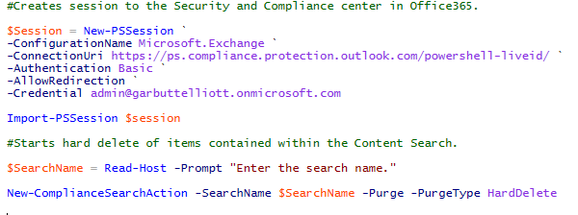

The name of the search can be copied out of the Content search web portal

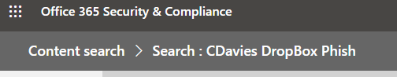

The name of the search above would be *CDavies DropBox Phish*.

You can verify the purge has completed by running the command: Get-ComplianceSearchAction

